PHÁT TRIỂN ỨNG DỤNG CHO THIẾT BỊ DI ĐỘNG

**Bài tập tuần 8**

**Bài1**

a.

## **- Bước 1:** Mở file strings bổ sung các câu lệnh sau:

<**string name="same_day_messenger_service"**>Same day messenger service</**string**>

<**string name="next_day_ground_delivery"**>Next day ground delivery</**string**>

<**string name="pick_up"**>Pick up</**string**>

## - **Bước 2:** Bổ sung 3 RadioButton bằng cách bổ sung các câu lệnh sau vào file activity_oder.xml

<RadioGroup

android:layout_width="wrap_content" android:layout_height="wrap_content" android:layout_marginLeft="24dp" android:layout_marginBottom="24sp" android:orientation="vertical" app:layout_constraintStart_toStartOf="parent" app:layout_constraintTop_toBottomOf="@id/delivery_label"

>

<RadioButton

android:id="@+id/sameday" android:layout_width="wrap_content" android:layout_height="wrap_content" android:onClick="onRadioButtonClicked" android:text="@string/same_day_messenger_service" app:layout_constraintStart_toStartOf="parent" app:layout_constraintTop_toBottomOf="@+id/delivery_label" />

<RadioButton

android:id="@+id/nextday" android:layout_width="wrap_content" android:layout_height="wrap_content" android:onClick="onRadioButtonClicked" android:text="@string/next_day_ground_delivery" app:layout_constraintStart_toStartOf="parent" app:layout_constraintTop_toBottomOf="@+id/sameday1" />

<RadioButton

android:id="@+id/pickup" android:layout_width="wrap_content" android:layout_height="wrap_content" android:text="@string/pick_up" android:onClick="onRadioButtonClicked" app:layout_constraintStart_toStartOf="parent"

app:layout_constraintTop_toBottomOf="@+id/nextday" />

</**RadioGroup**>

**- Bước 3:** Trong class **OderActivity**, bổ sung 2 phương thức sau:

**public void** displayToast(String massage) { Toast.*makeText*(getApplicationContext(), massage, Toast.***LENGTH_LONG***).show();

}

**public void** onRadioButtonClicked(View view) {

**boolean** checked = ((RadioButton) view).isChecked();

**switch** (view.getId()) { **case** R.id.***sameday1***: **if**(checked) {

displayToast(getString(R.string.***same_day_messenger_service***));

break;

}

**case** R.id.***nextday***:

**if**(checked) { displayToast(getString(R.string.***next_day_ground_delivery***)); **break**;

}

**case** R.id.***pickup***:

**if**(checked) {

displayToast(getString(R.string.***pick_up***));

break;

}

default:

break;

}

}

# Chạy chương trình

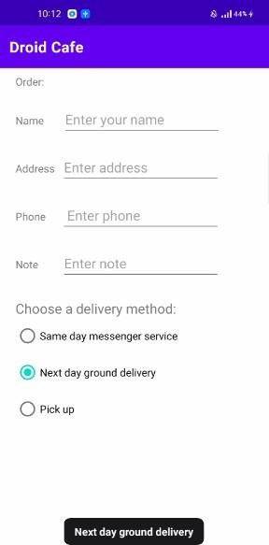

**Coding Challenge**

**- Bước 1:** Trong Class OrderActivity bổ sung thêm thuộc tính RadioButton **radioButton**

## - **Bước 2**: Trong phương thức onCreate() bổ sung các câu lệnh sau:

**radioButton** = findViewById(R.id.***nextday***);

**radioButton**.setChecked(**true** );

# Kết quả chạy chương trình:

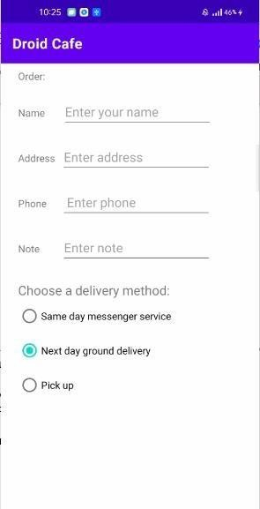

**b.**

**- Bước 1:** Bổ sung vào file strings đoạn code sau:

<string-array name="labels_array">

<**item**>Home</**item**>

<**item**>Work</**item**>

<**item**>Mobile</**item**>

<**item**>Other</**item**>

</string-array>

## - **Bước 2:** Thêm 1 Spinner vào file activity_order.xml như sau:

<Spinner

android:id="@+id/label_spinner" android:layout_width="0dp" android:layout_height="wrap_content" android:layout_marginStart="8dp" android:layout_marginTop="24dp" android:layout_marginEnd="24dp" app:layout_constraintEnd_toEndOf="parent" app:layout_constraintStart_toEndOf="@+id/phone_text"

app:layout_constraintTop_toBottomOf="@+id/address_text" />

## - **Bước 3:** Trong phương thức onCreate(), bổ sung đoạn mã sau:

Spinner spinner = findViewById(R.id.***label_spinner***);

**if**(spinner != **null**) { spinner.setOnItemSelectedListener(**this**);

}

ArrayAdapter<CharSequence> adapter = ArrayAdapter.*createFromResource*(**this**, R.array.***labels_array***, android.R.layout.***simple_spinner_item***); adapter.setDropDownViewResource(android.R.layout.***simple_spinner_dropdown_item***); **if**(spinner != **null**) {

spinner.setAdapter(adapter);

}

- **Bước 4:** Cho Class OrderActivity thực thi giao diện **AdapterView.OnItemSelectedListener.**

Đồng thời ghi đè 2 phương thức **onItemSelected**() và **onNothingSelected**() như sau:

@Override

**public void** onItemSelected(AdapterView<?> parent, View view, **int** position, **long** id) { String spinnerLabel = parent.getItemAtPosition(position).toString(); displayToast(spinnerLabel);

}

@Override

**public void** onNothingSelected(AdapterView<?> parent) {

}

# Chạy chương trình:

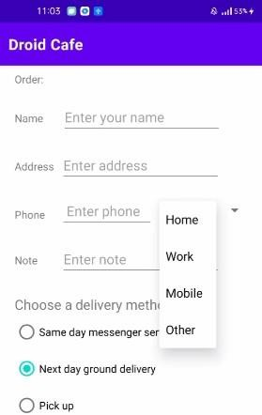 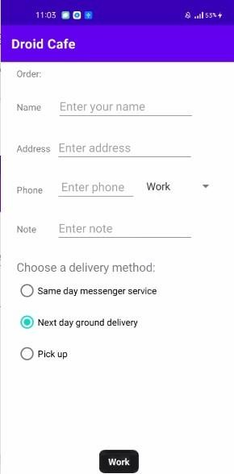

# Coding challenge 2

* **Bước 1:** Tạo Project mới

## **Bước 2:** Thêm 1 TextView và 1 EditText như sau:

<TextView

android:id="@+id/textView2" android:layout_width="wrap_content" android:layout_height="wrap_content" android:layout_marginStart="36dp" android:layout_marginTop="32dp" android:text="Nhập SĐT" app:layout_constraintBottom_toBottomOf="parent" app:layout_constraintStart_toStartOf="parent"

app:layout_constraintTop_toTopOf="parent" app:layout_constraintVertical_bias="0.372" />

<EditText

android:id="@+id/editTextPhone" android:layout_width="wrap_content" android:layout_height="wrap_content" android:layout_marginTop="32dp" android:ems="10" android:inputType="phone" android:imeOptions="actionSend" app:layout_constraintEnd_toEndOf="parent"

app:layout_constraintStart_toStartOf="parent" app:layout_constraintTop_toBottomOf="@+id/textView2" />

## **Bước 3:** Trong class MainActivity, viết thêm phương thức dialNumber như sau:

**private void** dialNumber() {

*// Find the editText_main view.*

EditText editText = findViewById(R.id.***editTextPhone***); String phoneNum = **null**;

*// If the editText field is not null,*

*// concatenate "tel: " with the phone number string.*

**if** (editText != **null**) phoneNum = **"tel:"** + editText.getText().toString();

*// Optional: Log the concatenated phone number for dialing.*

Log.*d*(***TAG***, **"dialNumber: "** + phoneNum);

*// Specify the intent.*

Intent intent = **new** Intent(Intent.***ACTION_DIAL***);

*// Set the data for the intent as the phone number.*

intent.setData(Uri.*parse*(phoneNum));

*// If the intent resolves to a package (app),*

*// start the activity with the intent.*

**if** (intent.resolveActivity(getPackageManager()) != **null**) { startActivity(intent);

} **else** {

Log.*d*(**"ImplicitIntents"**, **"Can't handle this!"**);

}

}

## -**Bước 4:** Viết lại phương thức onCreate() như sau:

**protected void** onCreate(Bundle savedInstanceState) { **super**.onCreate(savedInstanceState); setContentView(R.layout.***activity_main***);

EditText editText = findViewById(R.id.***editTextPhone***);

**if** (editText != **null**) editText.setOnEditorActionListener

(**new** TextView.OnEditorActionListener() { @Override

**public boolean** onEditorAction(TextView v, **int** actionId, KeyEvent

event) {

**boolean** handled = **false**;

**if** (actionId == EditorInfo.***IME_ACTION_SEND***) { dialNumber();

handled = **true**;

}

**return** handled;

}

*// If view is found, set the listener for editText.*

});

}

# Chạy chương trình:

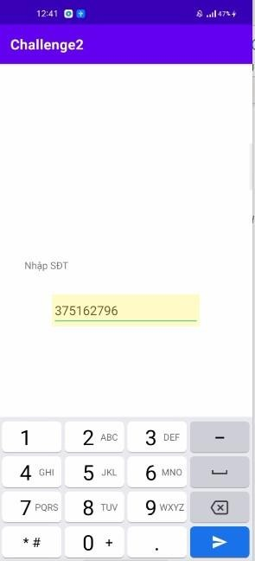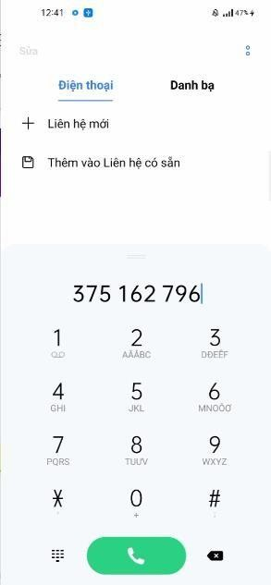

**c.**

**- Bước 1:** Tạo Project mới

## - **Bước 2:** Mở file strings thêm đoạn code sau:

<**string name="app_name"**>Homework_4.2</**string**>

<**string name="chocolate_syrup"**>Chocolate syrup</**string**>

<**string name="spinkles"**>Spinkles</**string**>

<**string name="crushed_nuts"**>Crushed nuts</**string**>

<**string name="cherries"**>Cherries</**string**>

<**string name="orio_cookie_crumbles"**>Orio cookie crumbles</**string**>

## - **Bước 3:** Thêm 5 Checkbox và 1 Button vào file activity_main.xml như sau:

<CheckBox

android:id="@+id/checkBox" android:layout_width="wrap_content" android:layout_height="wrap_content" android:layout_marginStart="32dp" android:layout_marginTop="70dp" android:onClick="clicked" android:text="@string/chocolate_syrup" app:layout_constraintStart_toStartOf="parent" app:layout_constraintTop_toTopOf="parent" />

<CheckBox

android:id="@+id/checkBox2" android:layout_width="wrap_content" android:layout_height="wrap_content" android:layout_marginStart="32dp" android:layout_marginTop="32dp" android:onClick="clicked" android:text="@string/spinkles" app:layout_constraintStart_toStartOf="parent" app:layout_constraintTop_toBottomOf="@+id/checkBox" />

<CheckBox

android:id="@+id/checkBox3" android:layout_width="wrap_content" android:layout_height="wrap_content" android:layout_marginStart="32dp" android:layout_marginTop="32dp" android:onClick="clicked" android:text="@string/crushed_nuts" app:layout_constraintStart_toStartOf="parent" app:layout_constraintTop_toBottomOf="@+id/checkBox2" />

<CheckBox

android:id="@+id/checkBox4" android:layout_width="wrap_content" android:layout_height="wrap_content" android:layout_marginStart="32dp" android:layout_marginTop="32dp"

android:onClick="clicked" android:text="@string/cherries" app:layout_constraintStart_toStartOf="parent" app:layout_constraintTop_toBottomOf="@+id/checkBox3" />

<CheckBox

android:id="@+id/checkBox5" android:layout_width="wrap_content" android:layout_height="wrap_content" android:layout_marginStart="32dp" android:layout_marginTop="32dp" android:onClick="clicked" android:text="@string/orio_cookie_crumbles" app:layout_constraintStart_toStartOf="parent" app:layout_constraintTop_toBottomOf="@+id/checkBox4" />

<Button

android:id="@+id/button" android:layout_width="wrap_content" android:layout_height="wrap_content" android:layout_marginStart="32dp" android:layout_marginTop="32dp" android:text="Show Toast" android:onClick="showToast" app:layout_constraintStart_toStartOf="parent"

app:layout_constraintTop_toBottomOf="@+id/checkBox5" />

## **Bước 4:** Trong class MainActivity, bổ sung các phương thức sau:

**public void** displayToast(String message) { Toast.*makeText*(getApplicationContext(), message, Toast.***LENGTH_LONG***).show();

}

**public void** clicked(View view) {

**boolean** checkClicked = ((CheckBox)view).isChecked();

**switch** (view.getId()) {

**case** R.id.***checkBox*** :

**if**(checkClicked) {

**str** = **str** + **" "** + getString(R.string.***chocolate_syrup***);

break;

}

**case** R.id.***checkBox2*** :

**if**(checkClicked) {

**str** = **str** + **" "** + getString(R.string.***spinkles***);

break;

}

**case** R.id.***checkBox3*** :

**if**(checkClicked) {

**str** = **str** + **" "** + getString(R.string.***crushed_nuts***);

break;

}

**case** R.id.***checkBox4*** :

**if**(checkClicked) {

**str** = **str** + **" "** + getString(R.string.***cherries***);

break;

}

**case** R.id.***checkBox5*** :

**if**(checkClicked) {

**str** = **str** + **" "** + getString(R.string.***orio_cookie_crumbles***);

break;

}

}

}

**public void** showToast(View view) { displayToast(**str**);

}

# Chạy chương trình:

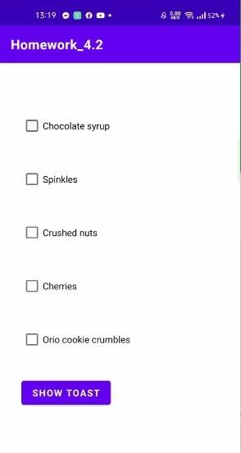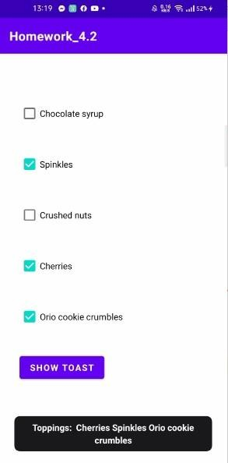

**Answer these questions**

## Question 1

What's the most important difference between checkboxes and a RadioGroup of radio buttons? Choose one:

* + The only difference is in how they appear: checkboxes show a checkmark when selected, while circular "radio" buttons appear filled when selected.
  + CheckBox elements in the layout can use the android:onClick attribute to call a handler when selected.
  + The major difference is that checkboxes enable multiple selections, while a RadioGroup allows only one selection.

Question 2

Which layout group lets you align a set of CheckBox elements vertically? Choose one:

* + RelativeLayout
  + LinearLayout
  + ScrollView Question 3

Which of the following is the method of the [Checkable](https://developer.android.com/reference/android/widget/Checkable.html) interface to check the state of a radio

button (that is, whether it has been selected or not)?

* + getId()
  + isChecked()
  + onRadioButtonClicked()
  + onClick()

**Bài 2. a.**

**Task 1: Add items to the options menu**

* **Bước 1:** Tạo file **context_menu.xml**
* **Bước 2:** Bổ sung đoạn mã sau vào file **context_menu.xml**

<item

android:id="@+id/action_order" android:orderInCategory="10" android:title="Order" app:showAsAction="never"

/>

<item

android:id="@+id/action_status" android:orderInCategory="20" android:title="Status" app:showAsAction="never"

/>

<item

android:id="@+id/action_favorites" android:orderInCategory="30" android:title="Favorites" app:showAsAction="never"

/>

<item

android:id="@+id/action_contact" android:orderInCategory="40" android:title="Contact" app:showAsAction="never"

/>

## - **Bước 3:** Mở file strings bổ sung đoạn mã sau

<**string name="action_order_message"**>You selected Order.</**string**>

<**string name="action_status_message"**>You selected Status.</**string**>

<**string name="action_favorites_message"**>You selected Favorites.</**string**>

<**string name="action_contact_message"**>You selected Contact.</**string**>

## **- Bước 4:** Trong class MainActivity, viết thêm phương thức sau:

**public boolean** onCreateOptionsMenu(Menu menu) { getMenuInflater().inflate(R.menu.***context_menu***, menu); **return super**.onCreateOptionsMenu(menu);

}

# Chạy chương trình:

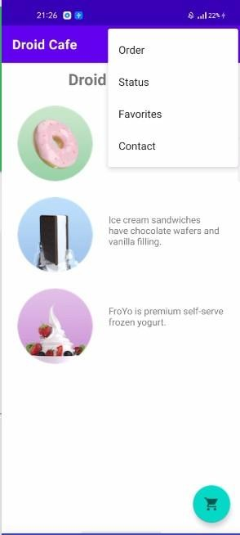

**Task 2: Add icons for menu items**

**-** Viết lại như sau đoạn mã trong **menu_main.xml** như sau:

<item

android:id="@+id/action_order" android:orderInCategory="10" android:title="Order" android:icon="@drawable/ic_shopping_cart" app:showAsAction="always"

/>

<item

android:id="@+id/action_status" android:orderInCategory="20" android:icon="@drawable/ic_status_info" android:title="Status" app:showAsAction="always"

/>

<item

android:id="@+id/action_favorites" android:orderInCategory="30" android:icon="@drawable/ic_favorite" android:title="Favorites" app:showAsAction="ifRoom"

/>

<item

android:id="@+id/action_contact" android:orderInCategory="40" android:title="Contact" app:showAsAction="never"

/>

# Chạy chương trình

Dto id C aIe

Droid Desserts



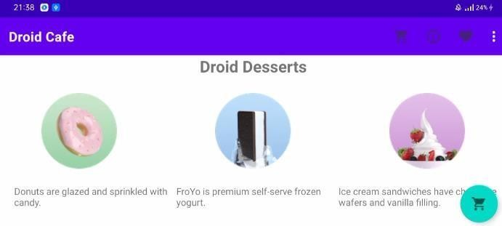

# Task 3: Handle the selected menu item

**-** Trong class **MainActivity**, viết lại phương thức **onOptionsItemSelected**() như sau:

**public boolean** onOptionsItemSelected(@NonNull MenuItem item) {

**switch** (item.getItemId()) {

**case** R.id.***action_order***:

Toast.*makeText*(getApplicationContext(), R.string.***action_order_message***, Toast.***LENGTH_LONG***).show();

Intent intent = **new** Intent(MainActivity.**this**, OrderActivity.**class**); intent.putExtra(***EXTRA_MESSAGE***, **mOrderMessage**); startActivity(intent);

return true;

**case** R.id.***action_status***:

Toast.*makeText*(getApplicationContext(), R.string.***action_status_message***, Toast.***LENGTH_LONG***).show();

return true;

**case** R.id.***action_favorites***: Toast.*makeText*(getApplicationContext(),

R.string.***action_favorites_message***, Toast.***LENGTH_LONG***).show();

return true;

**case** R.id.***action_contact***:

Toast.*makeText*(getApplicationContext(), R.string.***action_contact_message***, Toast.***LENGTH_LONG***).show();

return true;

}

**return super**.onOptionsItemSelected(item);

}

# Chạy chương trình

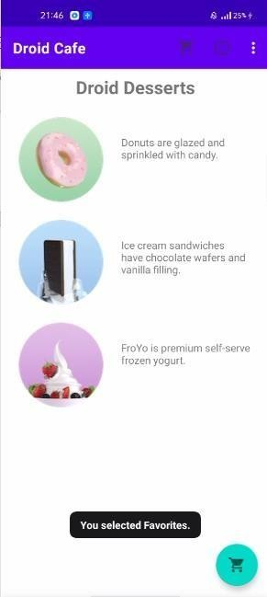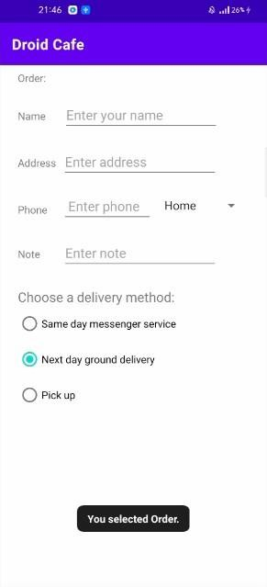

**Task 4: Use a dialog to request a user's choice**

* **Bước 1:** Tạo Project mới **Dialog For Alert**

## **Bước 2:** Thêm 1 TextView, và 1 Button như sau:

<TextView

android:id="@+id/textView" android:layout_width="wrap_content" android:layout_height="wrap_content" android:text="Hello World! Tap to test the alert: " app:layout_constraintBottom_toBottomOf="parent" app:layout_constraintLeft_toLeftOf="parent" app:layout_constraintRight_toRightOf="parent" app:layout_constraintTop_toTopOf="parent" />

<Button

android:id="@+id/button" android:layout_width="wrap_content" android:layout_height="wrap_content" android:layout_marginTop="8dp" android:text="Alert" android:onClick="onClickShowAlert" app:layout_constraintEnd_toEndOf="parent" app:layout_constraintStart_toStartOf="parent"

app:layout_constraintTop_toBottomOf="@+id/textView" />

- **Bước 3:** Trong class MainActivity, viết phương thức **onClickShowAlert** như sau:

**public void** onClickShowAlert(View view) {

AlertDialog.Builder myAlertBuilder = **new** AlertDialog.Builder(MainActivity.**this**); myAlertBuilder.setTitle(**"Alert"**);

myAlertBuilder.setMessage(**"Click OK to continue, or Cancel to stop:"**); myAlertBuilder.setPositiveButton(**"OK"**, **new**

DialogInterface.OnClickListener() {

**public void** onClick(DialogInterface dialog, **int** which) {

*// User clicked OK button.*

Toast.*makeText*(getApplicationContext(), **"Pressed OK"**, Toast.***LENGTH_SHORT***).show();

}

});

myAlertBuilder.setNegativeButton(**"Cancel"**, **new**

DialogInterface.OnClickListener() {

**public void** onClick(DialogInterface dialog, **int** which) {

*// User cancelled the dialog.*

Toast.*makeText*(getApplicationContext(), **"Pressed Cancel"**, Toast.***LENGTH_SHORT***).show();

}

});

myAlertBuilder.show();

}

# Chạy chương trình:



Dialog For Alert

A I F R T

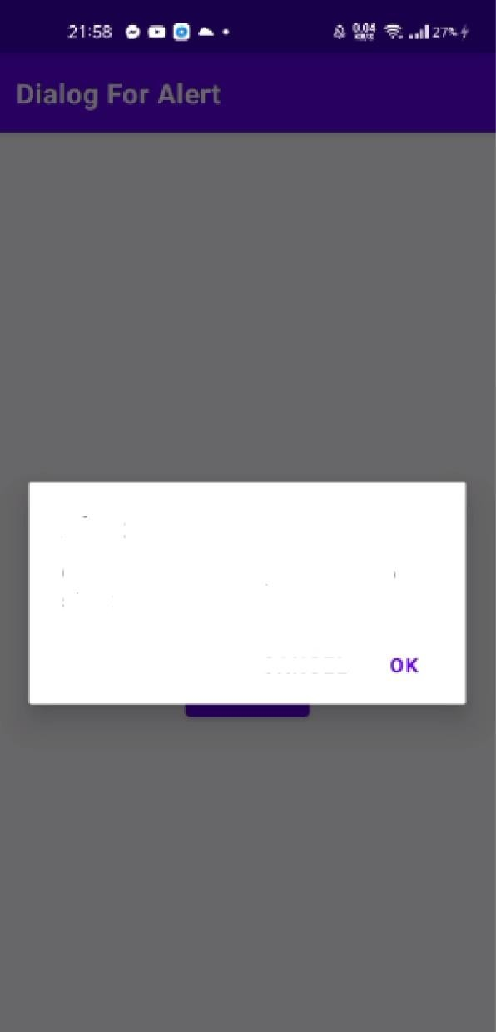

Alert

Click OK to continue, or Cancel to stop'

C AMCEL

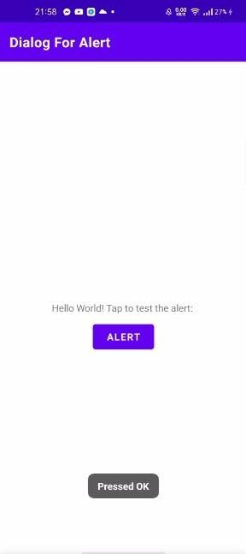

**b. Coding Challenge**

**- Bước 1:** Tạo Project mới

## - **Bước 2:** Thêm đoạn code sau vào file strings:

<**string name="article_title"**>Beatles Anthology Vol. 1</**string**>

<**string name="article_subtitle"**>Behind That Locked Door: Beatles Rarities!</**string**>

<**string name="article_text"**>In a vault deep inside Abbey Road Studios in London — protected by an unmarked, triple-locked, police-alarmed door — are something like 400 hours of unreleased Beatles recordings, starting from June 2, 1962 and ending with the very last tracks recorded for the <**i**>Let It Be</**i**> album. The best of the best

were released by Apple Records in the form of the 3-volume Anthology series.

For more information, see the Beatles Time Capsule at [www.rockument.com.](http://www.rockument.com/)

\n\n

This volume starts with the first new Beatle song, “Free as a Bird” (based on a John Lennon demo, found only on <**i**>The Lost Lennon Tapes Vol. 28</**i**>, and covers the very earliest historical recordings, outtakes from the first albums, and live recordings from early concerts and BBC Radio sessions.

\n\n

<**b**>Highlights include:</**b**>

\n\n

<**b**><**i**>Cry for a Shadow</**i**></**b**> - Many a Beatle fanatic started down the outtake road, like I did, with a first listen to this song. Originally titled “Beatle Bop” and recorded in a single session that yielded four songs (the other three featured Tony Sheridan with the Beatles as a backing band), “Cry for a Shadow” is an instrumental written by Lennon and Harrison, which makes it unique to this day. John Lennon plays rhythm guitar, George Harrison plays lead guitar, Paul McCartney plays bass, and Pete Best plays drums. The sessions were produced by Bert Kaempfert in Hamburg, Germany, during the Beatles’ second visit from April through July of 1961 to play in the Reeperbahn-section clubs.

\n\n

<**b**><**i**>My Bonnie</**i**></**b**> and <**b**><**i**>Ain’t She Sweet</**i**></**b**> — At the same session, the Beatles played on “My Bonnie” (the first-ever single with Beatles playing), as the backing band for English singer Tony Sheridan, originally a member of the Jets. The popularity of this single in Liverpool brought the Beatles to the attention of Brian Epstein, who worked in the NEMS record store and tried to meet demand for the disc. John Lennon then sings a fine “Ain’t She Sweet” (his first-ever released vocal).

\n\n

<**b**><**i**>Searchin</**i**></**b**> — A Jerry Leiber - Mike Stoller comedy song that was a hit for the Coasters in 1957, and a popular live favorite of the Beatles. The Coasters also had a hit with “Besame Mucho” and the Beatles covered that song as well. Ringo Starr had by now replaced Pete Best on drums. The high falsetto is George, who also plays a hesitant lead guitar. This is from their first audition for Decca Records in London on Jan 1., 1962, live in the studio. The Grateful Dead would later cover “Searchin” with a similar arrangement, Pigpen doing the Paul vocals. A live version is available on outtake records featuring the Dead joined by the Beach Boys!

\n\n

<**b**><**i**>Love Me Do</**i**></**b**> — An early version of the song, played a bit slower and with more of a blues feeling, and a cool bossa-nova beat in middle. Paul had to sing while John played harmonica — a first for the group. Pete Best played drums on this version.

\n\n

<**b**><**i**>She Loves You – Till There Was You – Twist and Shout</**i**></**b**> — Live at the Princess Wales Theatre by Leicester Square in London, attended by the Queen. “Till There Was You” (by Meredith Wilson) is from the musical The Music Man and a hit for Peggy Lee in 1961. Before playing it, Paul said it was recorded by his favorite American group, “Sophie Tucker” (which got some laughs). At the end, John tells the people in the cheaper seats to clap their hands, and the rest to “rattle your jewelry” and then announces “Twist and Shout” (a song by Bert Russell and Phil Medley that was first recorded in 1962 by the Isley Brothers). A film of the performance shows the Queen smiling at John’s remark.

\n\n

<**b**><**i**>Leave My Kitten Alone</**i**></**b**> — One of the lost Beatle songs recorded during the “Beatles For Sale” sessions but never released. This song, written by Little Willie John, Titus Turner, and James McDougal, was a 1959 R**&amp;**B hit for Little Willie John and covered by Johnny Preston before the Beatles tried it and shelved it.

A reference to a “big fat bulldog” may have influenced John’s “Hey Bulldog” (Yellow Submarine album), which is a similar rocker.

\n\n

<**b**><**i**>One After 909</**i**></**b**> — A song recorded for the <**i**>Let It Be</**i**> album was actually worked on way back in the beginning, six years earlier. This take shows how they did it much more slowly, with an R**&amp;**B feel to it.

</**string**>

<**string name="edit"**>Edit</**string**>

<**string name="share"**>Share</**string**>

<**string name="delete"**>Delete</**string**>

<**string name="edit_message"**>Edit choice clicked.</**string**>

<**string name="share_message"**>Share choice clicked.</**string**>

<**string name="delete_message"**>Delete choice clicked.</**string**>

- **Bước 3:** Thêm các **TextView** vào layout như sau:

<RelativeLayout xmlns:android="<http://schemas.android.com/apk/res/android>" xmlns:app="<http://schemas.android.com/apk/res-auto>" xmlns:tools="<http://schemas.android.com/tools>" android:layout_width="match_parent" android:layout_height="match_parent"

tools:context=".MainActivity">

<TextView

android:id="@+id/article_heading" android:layout_width="match_parent" android:layout_height="wrap_content" android:padding="10dp" android:text="@string/article_title" android:textStyle="bold"></TextView>

<ScrollView

android:layout_width="wrap_content" android:layout_height="wrap_content" android:layout_below="@id/article_heading">

<LinearLayout

android:layout_width="match_parent" android:layout_height="wrap_content" android:orientation="vertical">

<TextView

android:id="@+id/arcticle_subheading" android:layout_width="match_parent" android:layout_height="wrap_content" android:padding="10dp" android:text="@string/article_subtitle"></TextView>

<TextView

android:id="@+id/article" android:layout_width="match_parent" android:layout_height="wrap_content" android:autoLink="web" android:padding="10dp"

android:text="@string/article_text"></TextView>

</LinearLayout>

</**ScrollView**>

</RelativeLayout>

## - **Bước 4:** Mở class MainActivity, bổ sung và viết thêm các phương thức như sau:

@Override

**protected void** onCreate(Bundle savedInstanceState) { **super**.onCreate(savedInstanceState); setContentView(R.layout.***activity_main***);

TextView article_text = findViewById(R.id.***article***); registerForContextMenu(article_text);

}

@Override

**public void** onCreateContextMenu(ContextMenu menu, View v, ContextMenu.ContextMenuInfo menuInfo) {

**super**.onCreateContextMenu(menu, v, menuInfo); MenuInflater inflater = getMenuInflater(); inflater.inflate(R.menu.***context_menu***, menu);

}

@Override

**public boolean** onContextItemSelected(@NonNull MenuItem item) {

**switch** (item.getItemId()) {

**case** R.id.***context_edit***: displayToast(getString(R.string.***edit_message***)); **return true**;

**case** R.id.***context_share***: displayToast(getString(R.string.***share_message***)); **return true**;

**case** R.id.***context_delete***: displayToast(getString(R.string.***delete_message***)); **return true**;

default:

**return super**.onContextItemSelected(item);

}

}

**private void** displayToast(String message) { Toast.*makeText*(getApplicationContext(), message,

Toast.***LENGTH_SHORT***).show();;

}

# Chạy chương trình:



Behind That Locked Door: Beatles Rarities!

In a vault deep inside Abbey Road studios in London - protected by an mmarked, triple-locked. pollc alarmed door —a e somethlng like 40d hours of Unrelea9ed **69dtte5** reo0rdlngs, **starlJng frdm June**

2. 962 and ending with the very lest tracks recorded for lhe1erItBe album Thebestof thebest were released by Apple Records in lhe form of the 3-volume ArrtholDgy series. For mae intormat ion, see the Beark•s Time Capsule at **www pr:kument** rom.

This voMrne starts with the firsl oew Beetle song. Free as aBird” (basedon a John Lerlnon demo, found only unroe LostLennon apes Vol. 28, arclcows rhe very earliest historical recordings. outtakes from the fire albums, and live mco‹dings from early concerts end BBC Rad›o sessio»s.



**Czy' forg Sbadow** - Many e Beatle faaali0 started down me outtake road, like I did. *ei\h* first listen to this song Originally tilted -Beaile Bop" and recorded in a single session Addl yielded four songs (the othef three tea\ured Tony Gheriden w4hthe B9etTes as B bBck›ng band), ”Cry for a *Sfiabow-* is an instrumental written by Lennon andHarrison, which makes rt uniquetothls day. John Lennon plays rhythm quitar, George Harrlson plays lead gufrar, Paul McCartney plays bas3, an0 Pate Best plays drums Thesesslons we‹e p oduced dy Bert Kaempfert inHamburg, Germany, durlngtheBeatles' second visit from April through 4uty of 1961 to play in the Reegerbahn section clubs.

**My Borznfe** andA/nYSfra 5n'aar - at Lh9 same session, the Beatles pleyed on ”My Bonnie- (th» n w w‹f S1ftgl-0 wi\h Beatles playing}, as the baekmq band for English

in the I‘JEMSrecord store and tried to»eet demand for ihedisc. John Lennonthenslngs a fine "Ain't She Sweet" Els first-ever released vocal).

*5evre In — 4*Jerry Lefber - Mike Stoller comedy song thaiwas ahilfor theCoasters in195?.andapopular live favorite of the Beatles. Theco.esters also had B hit wrth "BeSpme Mucho- and the Belles Sovn,red that song as well. Ringo Starr had by now replaced Pete Best ondrums. Thehigh fatserto isGeorge, who also pl0ys a hesitant lead gultcr, This i8 from their first oudlli0n for Decca Recoos lrl London onJgf11,.1962, liveinthe studio. The Grateful Dead would later cover "Searchin" with asimilar arrangement. Pigpen doing the Paul vocals. Alie version isavailable on ou\lake records featuring theDead joined by the Beach Boys!

Lore gfeDo — Anearly verslon Of the song, playeda brt slower and with more of ablues feellng, and acool bossa-noma beat in middk•. Paulhad tosing while Jghp played harmgnic4 — a Fir${ fur lhe group. Pglg Best played drumu on this version.

she /.ones *You* - TU 7Jsere *Wac Von* - TMsr and 3fiout

— Llve at the Princess Wales Theatre by Le‹cesler Square in Londof?, Blended by the 0ueen. "Till There Was You"(by Meredith WlJson) 1s from the musical TheMuslc Man anda h‹l *for* Peggy Lee In1961. Before playing inPBMI S8Idit wss recorded by his favorite American group, -Sophie Tucker" (which got some laughs). it theend,John tells thepeople in

\he cheaper sea\s to c lap their hands, and the zest to

"ranle your jawel artd then annDunces hoist and Shout" (a songbyBert RussellandPhll Medley that wa9 first recorded In 1962 by lhelsley erOth+re). Afilm Df the performance shows theQueen smiling at John's remark

Leave Mtr VrttanAlone - One of thelost Beatlesongs recorded during the 'Beatles For Sale” sessions but

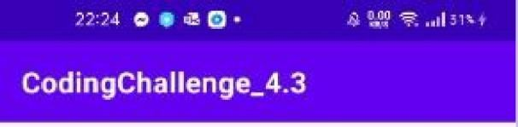

C odingC h aIIenge_4.3

**Beatles Amhology Vol. 1**

Behind That Locked Door.Beatles Rarities! Inavaultdeepinside Abbey Raad Studios in

London - protected by an unmarked, triple-locked,

police alQffT\ed door — BX S0fTl6thing like 400 hours of unrelea9ed 8eat1es recordings, startlng from June 2, 1962 andending with thevery lasttracks recorded for Ihe Tel it Be ‹lbum The besl of the best were released by Apple Records inthefurm uf the3-volume Anthology series. For more information, see the Beatles Time Capsule at



This volume starts with the first new Beatle song, "Free a6 0 Bird" (based or - '-“- ' ----- "--- ‘-'•-" only on 7he Loss Lennon

very earliest historical rer Edit first albums, and line rear

and BBC: Radio sessio»s.

Share

FfighFqhts include:

n » see -M» Delete the outtake road, like I di‹

song. 0rigin6l|y till9d "BedTIB wI0'r90 rrWU "

single session Ihaf yieldedluur sorxjs (the othur three featured Tony Sheridan withtfieBeatles BsBducking band), ”Cry for B 9hadow- is an instrumental written by Lennox and Ha f›son, whleh makes it urilque totile day. John Lennon plays rhythm guitai. George HBrrison plays lead guitar, Paul McCa rrney plays bass, and Pete Be6l plays drums. The ses slons we‹e produced 6y Bert Kaempf+rt in HBmburg, Germany, during the Bea Iles' secondvisit from Aprilthrouqh July of1961toplay in Ihe Peeperbahn•sect ion clubs.

**My'Borusie** and Ain"t Sfie Swaer - At the SBFTI€'! session, ihe Beatles played 0n "My Bonnle- rhefirst'q•er single with BestIegplaying), as thebacklogband for English singer Tony Sheridan. originBlly a mernb9F Of the Jets.

Thonnniilorhvml4his sin*zJoinIiwor mlhtminlet tho



Beatles **Anthology** Vol.

Behind T at Locked Doo

a

In B vauIt deep Inside Abbey Road Studios in

London - protected by an unmarked. triqle-locked, OlI06-8l8f¥t1ed door —are something lik:e 400 hours ofunreleased Beatles reeordJnqs, starting from June 2, 1962 andending with thevery last tracks recorded for the I.el it Be al0um The best of II e besr were released by Apple Re«urds in thefurm of li e 8-vulume AntholDgy series. For more information, see the Beatles Time Capsule at [www.rortument.Tom.](http://www.rortument.tom/)

h

1

r: Beatles R

rities!

This volume starts with the first new Beatle song, "Freeas aBird"(basedona John Lennondemo, found



very earllest historical recordings. arm akes from the *fret* albums, andlive recordings from early concerts and BBC Pad‹o sessions.

High sha include:

Ozy for a *Shedaw -* MZfty B Bea\Ie fanatlc started down the oultake road, like I did. with a first listen to this 6O0g. 0ngiFI6fler ti1l9d *BRotlg BOQ* 0I"Id r9C0rdl2d in B single se‹s1Ort thal yielded fuur song s (lhe other Ihree featured Tony Sheridan withMeBeatles as abacking band), "Cry fnr a.fihadow- is an instrumental written by Lennon and Hart›son, whlch makes It unlque la this day. John Lennon plays rhythm guitar. George Harrison plays Ie0d gunar, Paul McCartney plays bass, and Pete Besi plays drums. The sesliens Tele produced by Belt Kaempfert inHamburg, Germany, during theBeatles' B CDnd visit fr 61 to play in lhePeeperbal

*fvfil* Bonnie anb *Afin”tShe Swami* - At the same session, the Beatles playedon”My Bonnie- (thefirst ever single with Beatles. playing), a8 the backing band for E.ngl‹sh singer Tony Sheridan, originally amember of theJets.